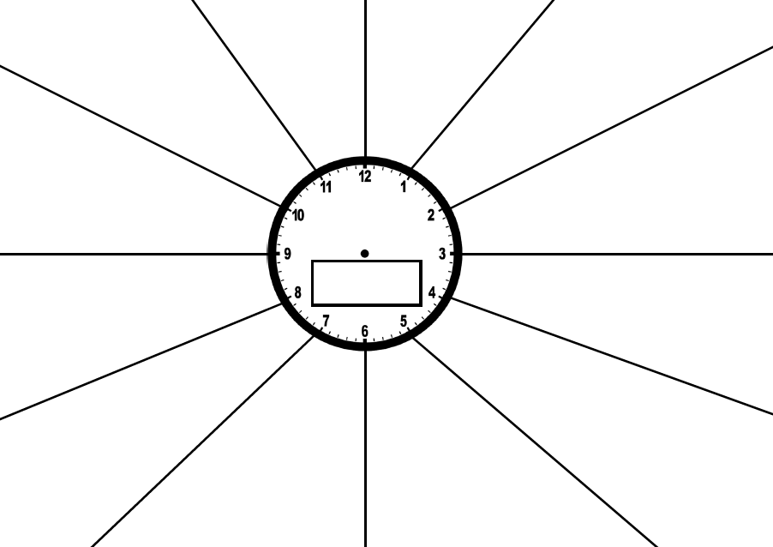

REVISION CLOCK

**Instructions: Break the topic down into 12 manageable sections. Spend 5 minutes making notes on each section. Add the name of the topic/unit of work to the centre of the clock.**